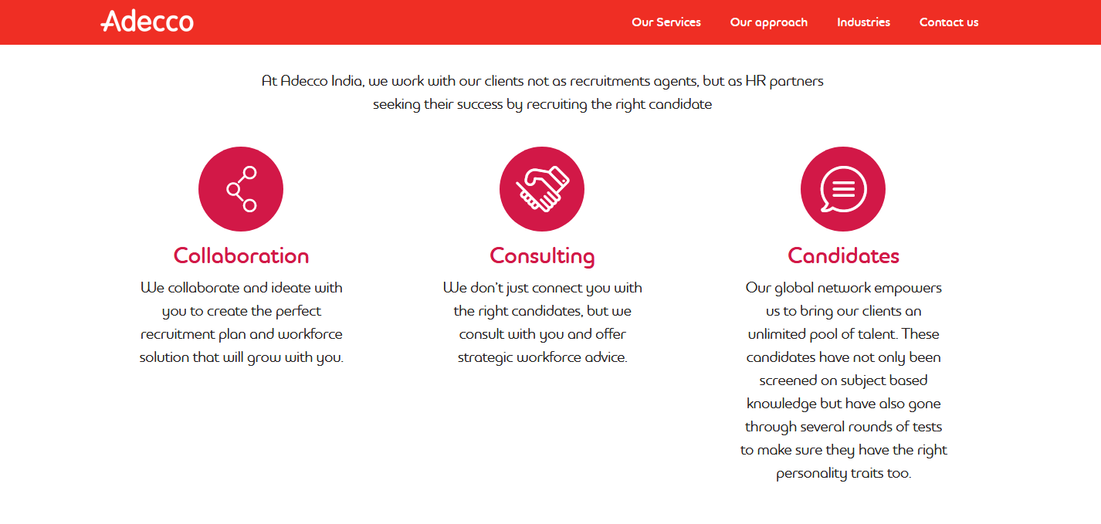url: <https://www.adecco.co.in/employers/our-approach>

How we help

At staffind, we work with our clients not as a recruitment agents, but as HR Partners seeking their success by recruiting the right candidate.

Our expert’s team develops and implement solutions for all your problems related to HR solutions. Staffind boasts of extensive network of temporary and permanent candidates, ensuring your right candidate is just a click away. We provide a fast and efficient reactive response, 24 hours a day, 7 days a week, from a consultant that knows you or your business.